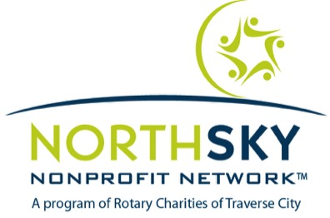

NORTHSKY LEADERSHIP COACHING
APPLICATION FORM

Deadline for application: September 20, 2017

Submit application to: Lucille Chrisman
lchrisman.coach@gmail.com

- Coaching will begin the week of October 3 and run through December 30, 2017
- Participants will receive 8 confidential individual sessions with a certified coach
- There will be 3 group cohort sessions
- Completion of a 360 Leadership Assessment
- Acceptance into the program is required and selections will be made by Lucille Chrisman
- Only 10 participants will be accepted
- Cost of the program is $1,600

General Information

Name of applicant:

Title:

Organization:

Organization address:

Organization phone:

Primary phone number:

Email address:

Organization Information

Length of time in present position:

Length of time with present organization:

Founding date of organization:

Number of full-time employees:

Size of Board:

What are the top 3 challenges/opportunities facing your organization today?

What are the top 3 challenges/opportunities you are experiencing as a leader within this organization?

Highlight your top 3 priorities you would like to focus on through this coaching program:

Identify my leadership style
Develop a leadership plan for further growth
Increase self-awareness as leader
Challenge yourself to be your best
Explore a career path forward
Understand how you sabotage yourself
Clarity of purpose and values
Create stronger working relationships
Work through a difficult challenge
Decrease blind spots
Build stronger teams
Learn how to make better decisions
Balance work and energy
Strengthen relationship with primary stakeholders
Make a critical decision
Learn how to be more effective with time
Increase knowledge on adaptive leaders of tomorrow
Communicate more effectively
Hold myself accountable for progress toward goals
Manage self and others more effectively
Increase confidence
Move beyond personal stops or blocks
Define where you are today to where you want in the future
Decrease stress
Other:

What are your top 3 organizational goals?

What are your biggest challenges in meeting these goals?

Please make any additional comments you believe are worthy of consideration in this application.

