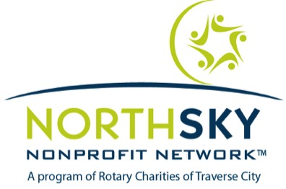

NORTHSKY LEADERSHIP COACHING
SCHOLARSHIP REQUEST

Name:

Organization:

Partial funding may be available to qualified applicants. To be considered for scholarship support, please provide the following information:

- The total coast of the Leadership Coaching program is $1,600 per participant. Please indicate the amount of scholarship you are requesting (scholarship amount up to $500):

- If scholarship support is provided, please indicate how the rest of the participant fee will be covered.

- If the total amount of scholarship support requested cannot be provided, do you want to be considered for a lesser amount?

________yes __________no

- Please indicate why you believe scholarship support for participation in the Leadership Coaching Program is important for you at this time.

- Please indicate how an investment of scholarship funds to support your participation in the Leadership Coaching program will facilitate greater community benefit.

