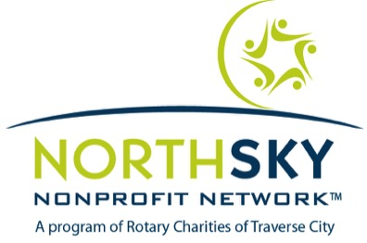

EXECUTIVE DIRECTOR PEER COACHING CIRCLE
APPLICATION FORM

Deadline for application: January 29, 2018
Send completed application to: Lucille Chrisman
lchrisman.coach@gmail.com

Program Details
- Limited to 8 participants
- Six – 2 hour sessions on dates/times determined by the group
- Cost: $285
- Required pre-meeting with facilitator
- Required confidentiality agreement signed before the start of the program

If you have questions please contact Lucille Chrisman at lchrisman.coach@gmail.com.

General Information

Name of applicant:

Name of nonprofit organization:

Nonprofit address:

Preferred telephone #:

Email address:

Organization Information

Length of time in present position:

Length of time with present organization:

Number of full time employees reporting to you:

Size of Governing Board:

Reasons for participating
Which of the following areas are of interest to you in joining an Executive Peer Coaching Circle:

__________ Engage with a trusted network of peers
__________ Create renewed energy and enthusiasm to lead
__________ Build stronger partnerships with other leaders
__________ Receive support and clarity on how to move forward
__________ Explore new approaches to organizational growth
__________ Explore your personal blocks to achieving desired goals
__________ Share knowledge and resources
__________ Learn coaching skills for moving individuals forward
__________ Practice leading from the center rather than at top
__________ Explore new ways of addressing complex challenges
__________ Expand your blind spots and receive feedback
__________ Create clarity around goals
__________ Re-energize your passion for creating change
__________ Improve relationships with your Board
__________ Practice communication skills in difficult situations
__________ Address feelings of isolation and burnout
__________ Address sustainability and succession planning
__________ Create balance between work and personal life
__________ Other:

Professional Goals

What are your top 3 professional goals this year?

What are your biggest challenges in reaching these goals?

In what ways do you hope a Peer Coaching Circle will support you in reaching your goals?

